**Worksheet 8 Name ____________ANSWERS______________ _____**

**32**

**MCSE 1 Sharing resources in a peer to peer network**

1. When are NTFS permissions used, (locally, remotely, both)?

[1] If a user logs in locally, only the NTFS permissions apply.

2. When are share permissions used, (locally, remotely, both)?

[1] When a user tries to access a shared folder from another computer

3. What 2 major pieces of information are found in a DACL?

[2] **ACE (Access Control Entry):** Identifies who has access to resources

**Permissions:** lists what level of permissions each ACE has

4. What do the letters ACE stand for and what is it?

[2] Access control entry: Identifies who has access to the resource

5. What type of computer authenticates users with domain accounts?

[1]

6. List the 3 share permissions.

[1] Read; Change; Full

7. List the 5 NTFS permissions for a file.

[2] Read; Read + Execute; Write; Modify; Full

8. List 2 additional things a user with Full Control can do that a user with Modify permissions cannot do.

[2] Take ownership; Assign permissions to other users

9. What is the difference between the group Everyone and the group Authenticated Users?

[1] **Authenticated users:** contain all users who login (except guest)

**Everyone:** is the same as Authenticated users and also contains the guest account.

10. What is the difference between the Users group and the Authenticated Users group?

[1] The administrator can **modify the membership list** of this group but he **cannot view or change** the membership of the authenticated users group.

11. What type of users does not appear in the Authenticated Users, Everyone, or Users groups?

[1] Everyone

12. What does it mean if you open the DACL of a folder and find the permissions are Greyed-out? (Don’t say “you can’t change them”, that’s obvious).

[1] If the permission is grayed-out, this **means the permissions were not inherited** which is why they cannot be changed.

13. If the permissions in a DACL are greyed-out, how do you change that so you can modify the permissions? List the steps as if you were telling someone how to do?

[2] You must break the inheritance:

Security Tab > Advanced > Permission > Untick Inherit from parent >

Remove inheritance OR copy them

14. In the Windows Explorer, how do you tell if a folder is shared with XP?

[1] In XP a shared folder is indicated by an icon with a hand below a folder.

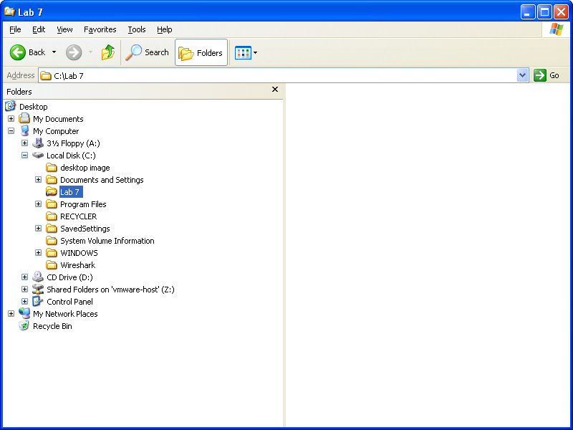

15. In the Windows Explorer, how do you tell if a folder is shared with Windows 10?

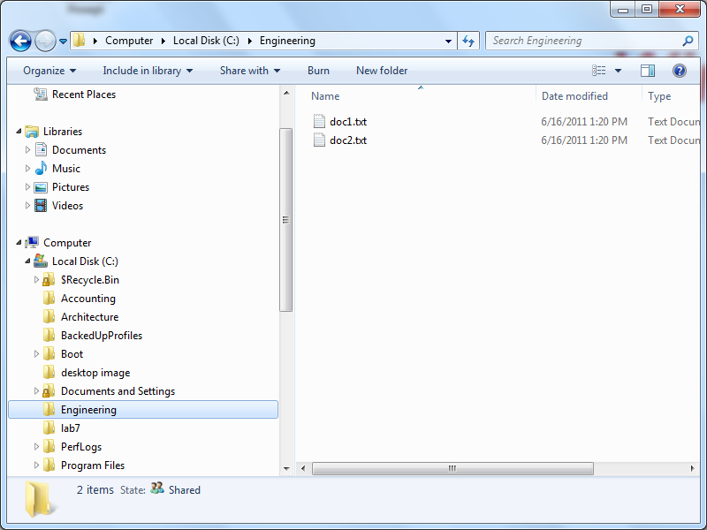[2] In Windows 10, a shared folder is indicated by a “shared” icon in the statusbar of the folder

16. What would you type at the command prompt to find out what folders are shared on a computer called neptune?

[1] net view \\ neptune

17. What is the full path to the folder where the SAM is found?

[1] C:\Windows\system32\config

18. What is a session ticket required for? How does a user get one?

[2] When the user is authenticated on the second computer, the second computer issues the user a **session ticket** which allows him to access resources on the second computer.

19. List the 3 methods of authenticating between two peer computers?

[3] - Have an account with identical username and password setup on the remote computer.

* Supply a username and password of a user on the remote computer when challenged to enter a username:password.
* Control Panel > User Accounts > Advanced > Manage Passwords >

Add a Windows Credential.

20. What would you type on a Windows 10 machine to find out what groups you belong to? Supply two methods.

[2] gpresult /R

Whoami /groups > group-list.txt

21. How do you save the output of a DOS command in a text file?

[2] by adding a **> group-list.txt** after a command